**Practical No.09**

1. **Write the program for the following:**

**a. Try to configure the widget with various options like: bg=”red”, family=”times”,**

**size=18 .**

**CODE:**

from tkinter import *

from math import factorial

win = Tk()

win.title("widgett.window")

win.geometry("400x500")

l0= Label(win,text='Factorial Calculator',bg='lightblue',font=('times',20))

l0.pack(pady=10)

def fact():

try:

nm=int(ety.get())

res=factorial(nm)

res_label.config(text=f'factorial of {nm} is {res}')

except ValueError:

res_label.config(text='enter valid number')

l1=Label(win,text='enter the number :',font=('times',20))

l1.pack()

ety = Entry(win,font=('times',10))

ety.pack(pady=20)

btn=Button(win,text='Calculate_Factorial',bg='lightblue',font=('times',20),command=fact)

btn.pack(pady=10)

res_label=Label(win,text="",bg='pink',font=('times',20))

res_label.pack(pady=10)

win.mainloop()

**OUTPUT:**

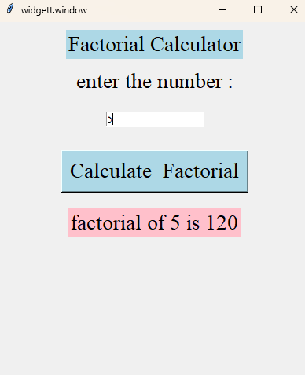

**b. Try to change the widget type and configuration options to experiment with**

**other widget types like Message, Button, Entry, Checkbutton, Radiobutton, Scale**

**etc.**

**CODE:**

from tkinter import *

from tkinter import messagebox

def submit_form():

nm=ety_nm.get()

ag=scale_age.get()

gender=gender_var.get()

if not nm:

messagebox.showwarning('input Error','please enter valid name')

else:

messagebox.showinfo('form submited',f'Name: {nm}\nAge: {ag}\nGender: {gender}\nSubscribe to anime_web !')

win = Tk()

win.title("Registration Form")

win.geometry("500x500")

msg=Message(win,text='Fill out the form below:',width=500,font=('times',10),bg='pink')

msg.pack(pady=10)

l_nm=Label(win,text='Name:',font=('times',10))

l_nm.pack(pady=10)

ety_nm=Entry(win,font=('times',10))

ety_nm.pack()

l_ag=Label(win,text='Age:',font=('times',10))

l_ag.pack(pady=10)

scale_age=Scale(win,from_=10,to=100,orient='horizontal',font=('times',10))

scale_age.pack(pady=10)

gender=Label(win,text='Gender:',font=('times',10))

gender.pack(pady=10)

gender_var=StringVar(value='male')

rm=Radiobutton(win,text='male',variable=gender_var,value='male',font=('times',10))

rf=Radiobutton(win,text='female',variable=gender_var,value='female',font=('times',10))

rm.pack()

rf.pack()

nl=IntVar()

chk_nl=Checkbutton(win,text='subscribe to anime_web',variable=nl,font=('times',19),bg='orange',fg='white')

chk_nl.pack(pady=10)

s_btn=Button(win,text='Submit',command=submit_form,font=('times',19),bg='blue',fg='white')

s_btn.pack(pady=10)

win.mainloop()

**OUTPUT:**

